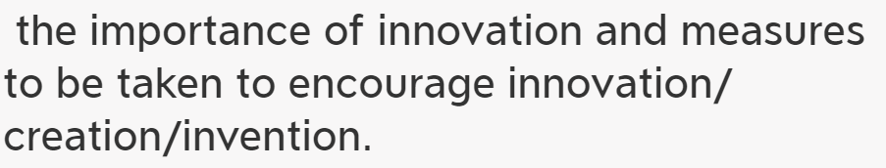

In the contemporary world, _______(主题词) have/has become increasingly important. It's of great necessity for___to______. The following solutions can account for this issue properly.

下面的解决方案可以很好地处理这个问题。

In the first place,there is no doubt that_________________Based on big data, most of _______ admitted that________(they've spent 2/3 of their time in doing sth.) Moreover，no one can deny that___________________.where there is/are__________________, there is/are______.Last but not least, I firmly believe that_________. The more responsibilities you have, the more repay you will get.越......， 越........

In conclusion, ___________.If we spare no efforts to_______, the future of _______ will be both hopeful and rosy.

In the contemporary world, innovation has become increasingly important. It's of great necessity for us students to have an innovative mind. The following solutions can account for this issue properly.

In the first place,there is no doubt that we should be curious all the time(curiosity does contribute to innovation.).Based on big data, most of successful social elites admitted that they've spent 2/3 of their time in learning(trying) new things. Moreover，no one can deny that we need to study more.(new inspiration can be enlightened by things we acquire everyday. ).Where there is knowledge, there are new ideas. Last but not least, I firmly believe that we need to be humble(humbleness is helpful to stimulate creation). The more humble you are, the more creative you will be.